TSRTC Hyderabad all depots bus schedules data analysis report
By: Nikhil VJ
Date: 8.Aug.2018
Status: v2
Initial notes:
1. File received from TSRTC having data for all depots in Hyderabad: TSRTC-alldepots-ORIG.csv
2. Download all related files here: http://nikhilvj.co.in/files/tsrtc/
3. Rudimentary GTFS feed for the full network is ready and available under “gtfs1” folder in above link.
4. Analysis sheets are stored together in “TSRTC-analysis.xlsx” file and the same is shared on google drive here. (I might create some charts there).
5. Programs were done in python jupyter notebooks which allow for exploratory programming and documentation, they are up in .ipynb format, on first link shared above.
6. This doc is split into 3 broad sections: Initial/GTFS, Analysis, Anomalies.

1. Initial processing, GTFS making

1.1. Stops
Sound some stray spaces/tabs in some stop entries (CURRENT_STAGE_NAME), shared it in anomalies section. Fixed them.
Filtered original csv to get unique listing of stops, 1737 total.
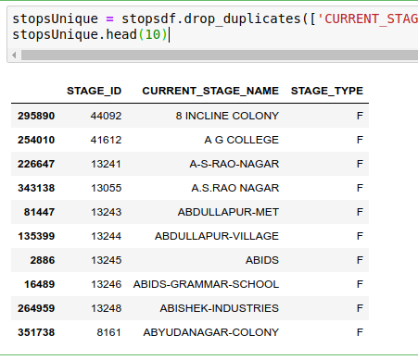
Assigned randomized lat-longs.
Then created stops.txt from that. Preserved the stage_type column as I expect it may be needed further along.
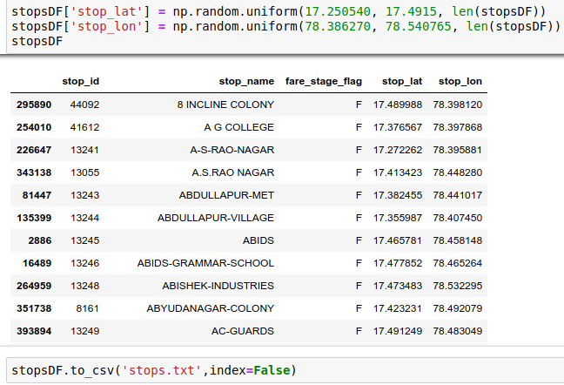

1.2. Routes
News: ROUTE_NAME from KCG file is replaced now by a ROUTE_NUMBER column, and it has a much better representation of actual route titles. (see a quick list of all routes in appendix section)

Filtered main csv to give unique entries by route_id, route_number and depot_code. Total 833.
There were anomalies, see anomalies section below for details.
Some route names have multiple route_id’s attached to them, so when counting by route_number column, there are 695 routes.
Created gtfs routes.txt. 833 routes total.

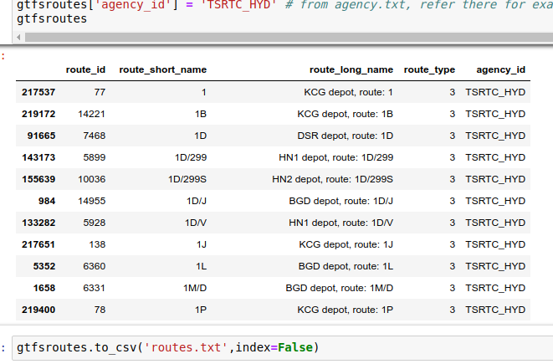

1.3. Calendar
Generated a GTFS id for calendar (also called service_id, don’t confuse it with TSRTC’s) for each trip by processing the OD_MON through OD_SUN columns. Got 29 calendar combinations total.
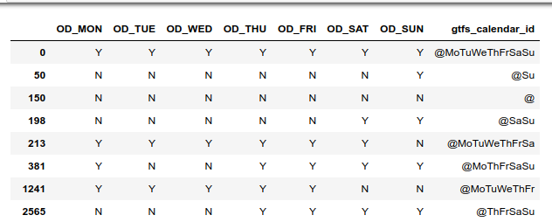

After generating the id’s, generated the gtfs calendar.txt file.
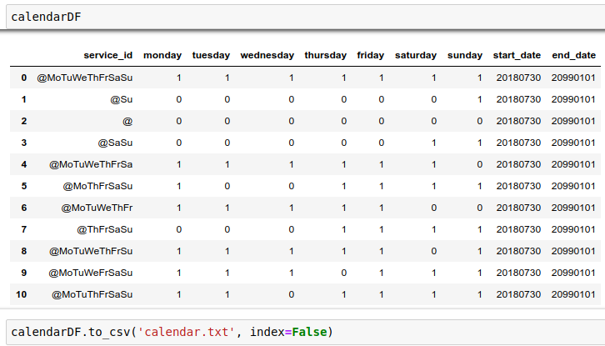

1.4. Trips
Grouped TSRTC file by trip_id. Trip_short_name field derived from route number, first stop’s time and direction.
35657 35550 trips total.
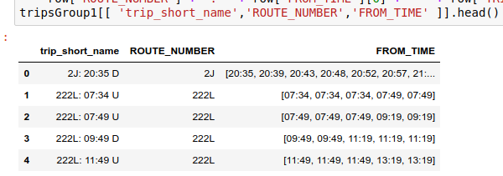

Created trips.txt :
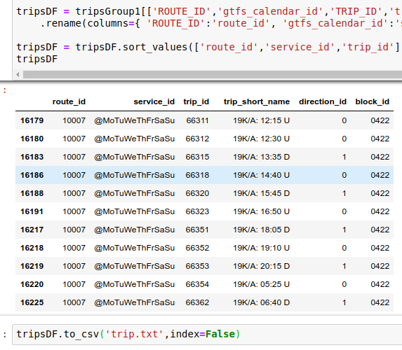
Used same trip_id as TSRTC’s TRIP_ID as it was unique dataset.
Used SERVICE_ID from the data as gtfs’s block_id field.

1.5. Stop_times
- Created.. 435,859 rows total.
- Have kept the sequence numbers as 10,20... instead of 1,2.. so that intermediate stops between stages can be inserted later on. The GTFS spec allows to use any numbers for sequence as long as they’re in ascending order.
- Arrival and departure timings are kept the same, based on FROM_TIME row.
- One change in values : in trips that cross midnight, 24hrs are added as per gtfs specs. (ex: 00:45 becomes 24:45) . For this, a new column FROM_TIME_NEW was created.
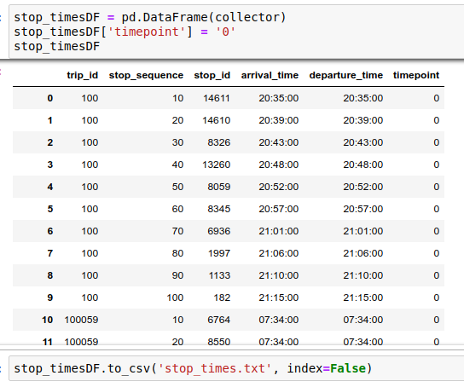

1.6. Validation of rudimentary GTFS feed
- Find full Validation report here: http://nikhilvj.co.in/files/tsrtc/gtfs1/validator-hydgtfs1.html
- No errors, many warnings.
- Created using same program as the one behind http://gtfsfeedvalidator.transitscreen.com but with longer listing for each type of error.

1.7. Visualization of rudimentary GTFS feed
Using ScheduleViewer by google transit
Instructions for running on windows:
- Go to https://github.com/google/transitfeed/releases
- Look for windows-binary (should be under the 1.2.15 one)
- Download and unzip
- Place the gtfs feed zip file in this unzipped folder, next to schedule_viewer.exe
- Double-click schedule-viewer.exe
- In the black box, type in the zip filename (including .zip extension) and press Enter
- Wait.. after many messages the black box will tell to open a URL
- Open http://localhost:8765 in your browser.

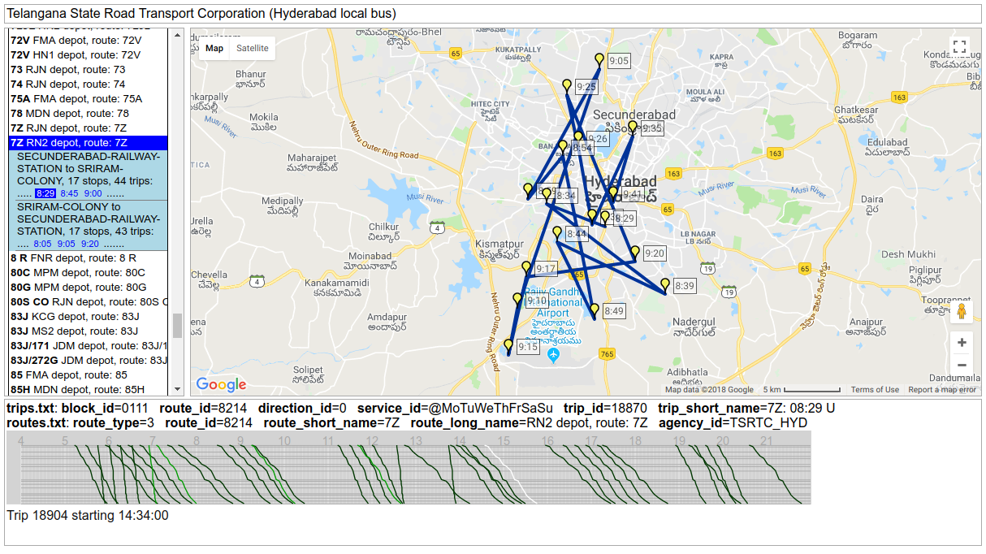
See full page screenshot here.

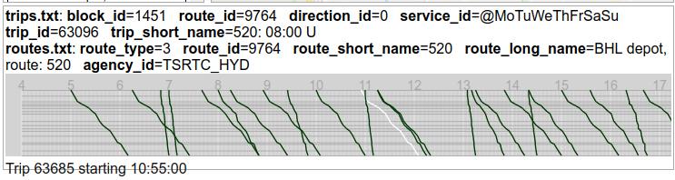
The trips timeline at bottom shows up trips that are criss-crossing, having too short times etc.

2. Analysis

2.1. Depot_code
['KCG', 'MI2', 'JDM', 'HN1', 'HN2', 'KGD', 'CNT', 'FMA', 'UPL',
'BKP', 'RN2', 'DSR', 'MPM', 'MS2', 'RJN', 'FNR', 'MS1', 'MHM',
'BGD', 'MDN', 'BHL', 'KPL', 'HPT', 'MI1', 'CCL', 'HCU', 'RN1']
27 Depots
Have to get the full names of these depots. See appendix .

2.2. Service_type
Frequency distribution of service_types
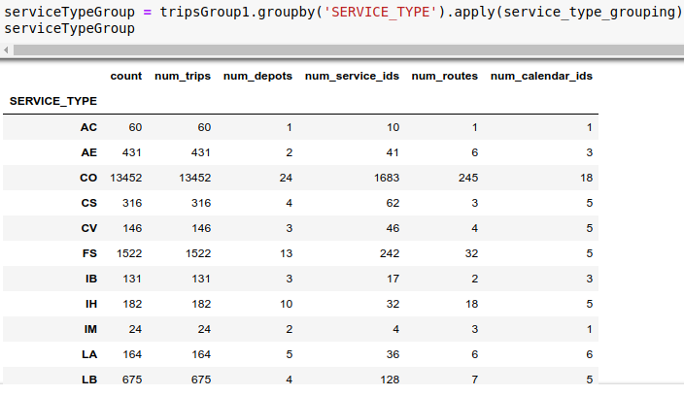
See sheet “serviceType_grouping” in analysis excel.
Service_type column has many types of services that need deciphering. See Appendix

2.3. Routes

2.3.1. Naming of routes
There are routes with are number-only, mixed (1B, 1M/D etc), and word (like GUNTUR, CTPL). Breakdown of numbers:
alphanumeric
mixed 528
number 121
word 46

2.3.2. Listing
Made a full listing of route_number and corresponding route_id and depot_code. Where repeats happen, they are concatenated.
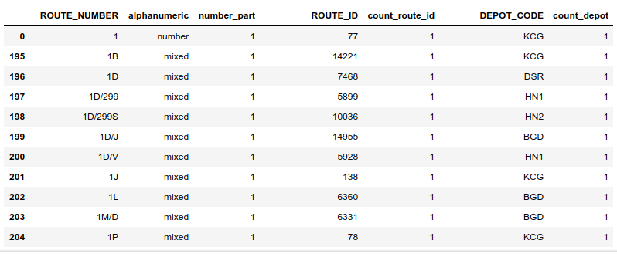
See “Route_id_depot_listing” in analysis excel

2.3.3. Routes-services mapping
We can compare this with MTD141 data.
See “Route_service_mapping” sheet in analysis excel.

2.3.4. Route-patterns mapping
Pattern: a sequence of stops covered in a trip.

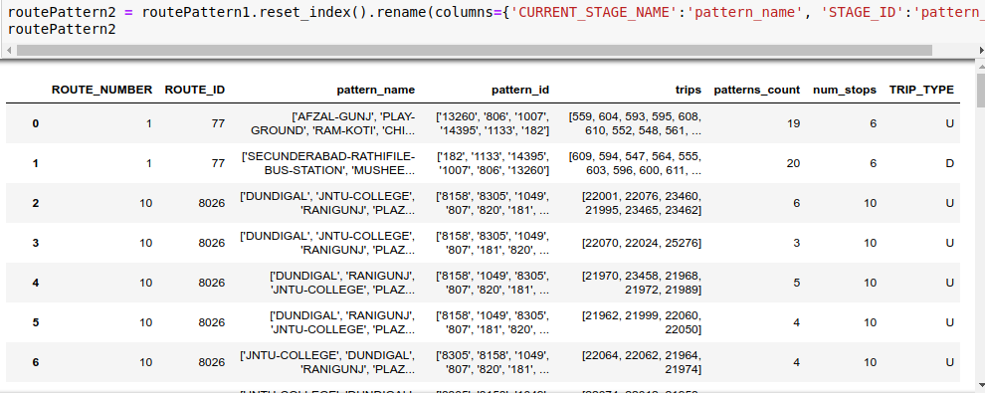
When grouping the whole dataset by patterns, it is found that there is one pair of up-down patterns that are repeating under both routes 1 and 1P.
Pattern Counts:
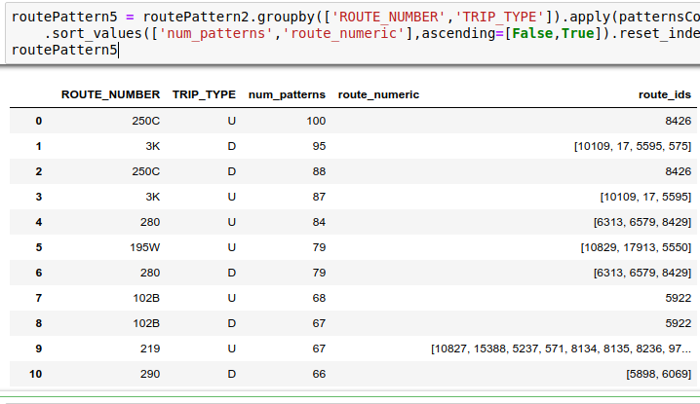
Route “250C” has highest number of varying patterns: 100 Up, 88 Down.
Out of 695, there are 384 routes that have just one Up pattern and one Down pattern. MPM depot has max, 36 such "proper" routes.

See “Route_patterns” and “Route_pattern_counts” sheets in analysis excel.

2.4. Trips

2.4.1. Lengths of trips
Frequency distribution made of how many trips or routes are 4 stops long, how many have 20 stops, etc.

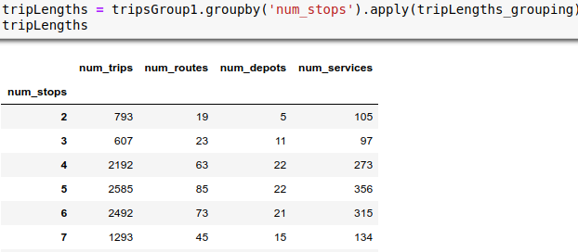
See sheet “TripLengths_grouping” in analysis excel.

2.4.2. Tripwise full listing
Grouped the csv data by Trip_id, to get each trip in its own row.
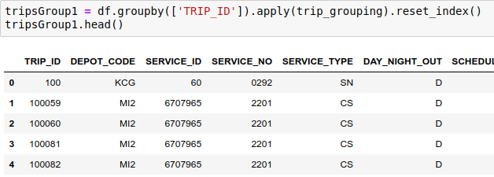
See “grouped-tripwise.csv” file. Saved this separately as it was large.

3. Issues, Anomalies
Suggestion: We could relay these back to TSRTC and they might make changes at source and give us fresh data.

3.1. Stop Anomalies

3.1.1. Leading or trailing spaces
Some stops have spaces or tabs in their names. ‘Trimmed’ them.

['S.R.NAGAR\t', 'EENADU\t', 'MUNICIPAL OFFICE\t', 'ECIL\t',
'AGRICULTURAL COLLEGE \t']

3.1.1. Repeating stops
Cases of different stop id’s, same name

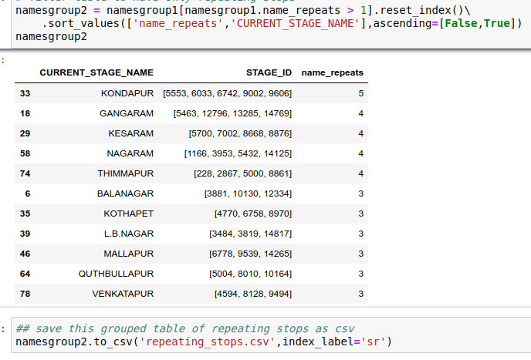
See “Stops_Repeating” sheet in analysis excel.

3.2. Route Anomalies

3.2.1. Blanks
Route_id 16390 has blank route_number value.
Have set it to ‘BLANK’ for now. Need to find out which route it originally is.
It has 37 trips total and is under CCL depot
Here is its stops sequence:

['CHENGICHERLA-DEPOT',
'CHENGICHERLA',
'RTC-COLONY-CHENEGICHERLA',
'MEDIPALLY',
'PEERAZADI-GUDA',
'UPPAL-BUS-STAND',
'MODERN-BAKERY',
'RAMANTHAPUR-PUBLIC-SCHOOL',
'AMBERPET-GANDHI-STATUE',
'KACHIGUDA',
'KOTI']

3.2.2. Leading or trailing spaces
ROUTE_ID 15296 had a leading space in its ROUTE_NUMBER : ‘ 212/568’
Have trimmed it.

3.2.3. Repeating routes
Route_number values are repeating in 97 cases.

Example:
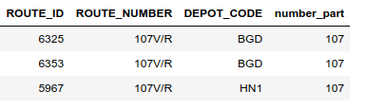

Listing made of repeating route_number values, with lists of route_ids and depot_codes.
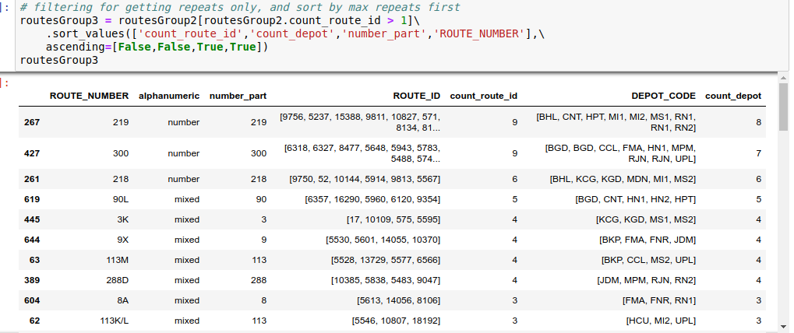
When counting by route_number, there are 695 unique names. (vs 833 unique id’s)
See “Routes_repeating” sheet in analysis excel.

3.2.4. Routes repeating in same depot
In a few cases, under the same depot there are instances of two route_id’s and same route_number title.
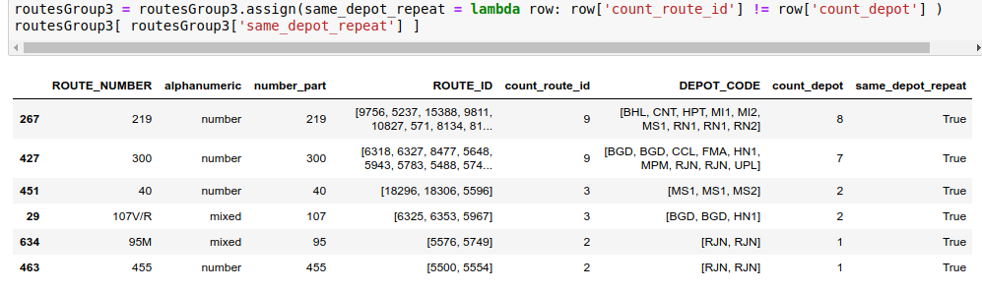
See “Routes_same_depot” in analysis excel.

3.2.5. Routes having only one direction
36 routes have only Up direction:
['22R' '455' '78' '95M' '120K' '14X' '16X' '188/251' '188H' '19F/A' '19KA'
'251J SU' '251M SU' '251P' '251SS' '2U' '449' '44EX' '450' '453' '454'
'532 HK' '73' '74' '8AU' '92' '92A' '92S' '94/95' '94K' '94R' '94U' '95N'
'95P' '95R' 'MP-NZB']

3 routes have only Down direction:
['288N/B' '90K' 'DVRM']

28 of these are under RJN depot.
Depot-wise counts of one-direction-only routes:
[RJN] 28
[CNT] 3
[MDN] 2
[FNR] 2
[MPM] 2
[KCG] 1
[HPT] 1

See “Route_pattern_counts” in analysis excel.

3.3. Timings/trips Anomalies

3.3.1. Blanks
5 trips under 2 routes had all timings cells as blank.
Route number 94U : trip_id 82427
Route number 567: trip_id: 96745, 96746, 96747, 96748
They were dropped from the data to process for now, as without timings info these cannot make valid gtfs.

3.3.2. Trips with only two stops
793 trips found having only two stops / stages.
They come under the following route numbers:
['MGBS-TIRUPATI', '1Z', '45F', '9F', 'B.PALLY-ATNR', '1B', '3H/N',
'190R', '113YK', '45RF', '6G', 'VJA', '158F/VSN', '10AS', '10F',
'KP', '19S/F', '19K/A', '158YF']

3.3.3. Odd timings
105 trips were found to have timings that were descending or irregular. See screenshot below.

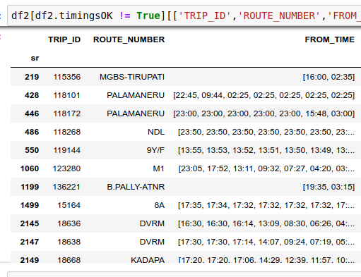

It is difficult to programmatically correct them. Some are simple cases of reversals, but in cases of trip crossing midnight, it is difficult to sift them out from trips that are simply problematic. So, for now, these 105 trips are also dropped out from the processed trip-wise data.
There are 60 routes under which they come, route VJA-ATNR has max odd trips at 8. Majority of the 60 routes have only 1 or 2 odd trips.

4. Appendix

4.1. All Route_number values
Listing of routes from their ROUTE_NUMBER values in the TSRTC file.
Note: subsequently, a blank one has been renamed to BLANK, and one having a leading space has been trimmed.

[, 212/568, 1, 10, 100, 100D, 100R, 101K/D, 102, 102/253L, 102A/G, 102B, 102B/218L, 102C, 102K, 102M, 102P, 102W, 103, 104A, 104A/216, 104M/127K, 104R, 104R/127K, 104R/218L, 104S, 105, 107J/21, 107JD, 107JS, 107JS-XC, 107V/R, 107VR, 107VR-ME, 107VR-SN, 10A/S, 10AS, 10BK, 10F, 10F/V, 10H, 10H/16A, 10H/25I, 10H/L, 10HA, 10K, 10K/L, 10K/P, 10KB, 10KJ, 10KM, 10L, 10L/18, 10Y/F, 10YF, 10YH, 113A, 113E/L, 113F, 113I/KP, 113I/M, 113I/V, 113K, 113K/225L, 113K/L, 113M, 113M/216, 113M/288, 113M/W, 113MG, 113Y, 113Y/K, 113YK, 115, 115C, 115M, 116, 116N, 116P, 117, 117L, 118D, 118G, 118H, 118P, 118W, 11W, 120, 120K, 120M, 123, 126/300, 126M, 127K, 127K/V, 127S, 127k, 136H, 136N, 142N, 147, 14X, 156, 156/118, 156/126, 156/216G, 156/288, 156/299, 156B/118, 156L, 156V, 158/277D, 158F, 158F/VSN, 158FV, 158J, 158J/L, 158JL, 158L, 158S, 158V/J, 158YF, 15H, 15H/242RG, 15IG, 16A, 16A-XC, 16A/219, 16A/226, 16A/49M, 16AK, 16AS, 16C, 16D, 16D-XC, 16R, 16V, 16X, 171, 171D, 171M, 171R, 171SM, 178F, 178G, 178K, 178N, 17D, 17H, 17H/10W, 17H/219, 17HN, 17HN/90LV, 17JJ, 17S, 17SP, 18/10K, 18/219, 185J, 186, 187, 187/224JN, 187B/C, 187D/V, 187K/V, 187P, 188/251, 188H, 189M, 189M/A, 189MQ, 18B, 18C, 18C/10J, 18C/250S, 18N, 18R, 18V, 190R, 193M, 193S, 194 H, 194B, 194V, 195W, 198, 199W, 19F, 19F/A, 19K, 19K/A, 19KA, 19KJ, 19M, 19S/F, 19V, 19YF, 1B, 1D, 1D/299, 1D/299S, 1D/J, 1D/V, 1J, 1L, 1M/D, 1P, 1P/25S, 1V, 1Z, 201, 201 G/I, 201G, 201K, 201M, 202T, 203A, 203A/M, 203A/R, 203K, 204, 204K, 204P, 204U, 205, 205A, 205B, 205M, 205T, 206, 208, 208C, 20P, 20P-SN, 20X/251, 21, 211A, 211B, 211C, 211D, 211DY, 211E, 211K, 211M, 211T, 211T/D, 211U, 212, 212/568, 212/570, 212/702, 216, 216K/L, 216L/W, 216LG, 216MG, 216T, 216W, 217, 217/300, 217A, 217D, 217M, 218, 218C, 218D, 218D/L, 218L, 218L/V, 219, 219-SU, 219/229, 21B, 21W, 220J, 220K, 220M, 220P, 220T, 220V, 222, 222A, 222L, 224/205F, 224G, 224HS, 224JW, 224K, 224X, 225, 225L, 226, 226L, 226M, 22D, 22K, 22M, 22R, 22T, 230A, 230D, 230P, 230V, 231K, 23B, 23GF-PC, 241T, 242, 242A, 242B, 242G, 242PG, 242RG, 245A, 245J, 24B, 24B-PC, 24B-PN, 24E, 24N, 24N/25S, 24S, 24S/219L, 24S/281E, 250/281, 250C, 251, 251AK, 251B, 251J SU, 251K, 251L, 251M SU, 251P, 251SS, 252, 252A, 252M, 252NP, 252S, 253G, 253H, 253K, 253KT, 253L, 253M, 253S, 253T, 254K, 254M, 25A, 25A/J, 25B, 25J, 25M, 25S, 26, 26G, 26M, 26N, 26S, 272, 272G, 277N, 279, 279-PA, 279R, 280, 280/564M, 280B, 280E, 280K, 280N, 280R, 280S, 280ST, 280T, 281, 283C, 283D, 283I, 283R, 283RG, 283S, 284P, 285 PS, 287N, 288, 288A, 288B, 288C, 288D, 288M, 288N/B, 288P, 288R, 288S, 288X, 288Y, 288Z, 289M, 290, 290/463, 290AF, 290F, 290K, 290K/P, 290U, 291, 293S, 299, 299H, 299M, 299P, 299S, 29B/272G, 29B/272I, 29B/272J, 29CD, 29R, 29S, 2C, 2J, 2U, 2Z, 3, 30, 30/280, 30/290U, 300, 300/126, 300/126M, 300/216, 30C, 30KPK, 30S, 316, 37, 37D, 38A, 38EX, 38S/47V, 38X, 3D, 3H, 3H/N, 3HN, 3K, 3K/252, 3KL, 3KN, 3M, 3Y, 40, 443N, 444, 445, 449, 44EX, 450, 451, 451M, 452, 453, 454, 455, 455M, 458, 45F, 45MF, 45RF, 460, 462, 463, 464, 47/224, 471, 471B, 471C, 472, 473D, 474, 475, 477, 478, 479, 47L, 47Y, 47YD, 47Z/C, 488, 49, 490, 490S, 491, 493, 494, 495G, 496, 497, 498KJ, 498VJ, 499, 49M, 49M/250, 49M/250C, 49M/251, 49M/T, 502, 503, 505, 50B, 51, 511B, 511D, 515, 516, 517, 518, 519, 520, 523K, 525, 526N/G, 527, 528, 530, 532, 532 HK, 535, 536, 537, 538, 540C, 540S, 543, 544, 545, 546, 567, 568, 571, 572, 572M, 573, 577, 578, 579, 580, 592, 593, 5G, 5GB, 5K, 5K/16A, 5K/16C, 5K/92, 5M-SN, 5MD, 5R, 5RW, 63M, 63S, 65, 65G, 65M, 65S, 65S/120, 66G, 67L, 67L/S, 67U, 6G, 6H/288, 6HN, 6LG, 6NG, 70, 70A, 71, 71A, 72H, 72J, 72JL, 72V, 73, 74, 75A, 78, 7Z, 8 R, 80C, 80G, 80S CO, 83J, 83J/171, 83J/272G, 85, 85H, 85Q, 85R, 85S, 85V, 85W, 85WS, 85j, 8A, 8A/16A, 8A/K, 8A/U, 8AU, 8C, 8J/M, 8JM, 8M, 8R, 90/251, 90D, 90D/47Y, 90K, 90K/253M, 90L, 90L/229, 90L/251, 90L/290F, 90N/U, 90R, 92, 92A, 92S, 94/95, 94C/70, 94K, 94R, 94U, 95K, 95M, 95N, 95P, 95R, 9E, 9F, 9K, 9K/272G, 9M, 9Q, 9X, 9X/171C, 9X/230X, 9Y/F, 9YFA, A1, A2, AMGL, B.PALLY-ATNR, B1, B2, BGLR, CHVL, CPL, CTPL, DVRM, ECIL X ROADS TO GHATKESAR, ECIL-AMALAPURAM, ECIL-GUNTUR, ECIL-RAZOLE, ECIL-TPT, GUNTUR, KADAPA, KNL, KP, M1, MARKAPURAM, MGBS-TIRUPATI, MP-NZB, MYP-GDK, MYP-KRMR, MYP-NZB, MYP-VJA, MYP-WGLL, NDL, NIZAMABAD-ARSP, NIZAMABAD-MBRK, ONGOLE, P1, PALAMANERU, PCPL, PULIVENDULA, THADIPATHRI, VIJAYAWADA, VJA, VJA-ATNR, WARANGAL, WARANGAL-BMRM, WARANGAL-PCM, YGT]

4.2. Service_type
Need to figure out what all these abbreviations stand for.
SERVICE_TYPE
AC
AE
CO
CS
CV
FS
IB
IH
IM
LA
LB
LN
MA
ME
MF
MO
MS
PA
PC
PM
PN
PO
PS
SA
SN
SU
VB
VC
VR
XC
XF
XG
XM
XS

4.3. Depot codes
depot_code
BGD
BHL
BKP
CCL
CNT
DSR
FMA
FNR
HCU
HN1
HN2
HPT
JDM
KCG
KGD
KPL
MDN
MHM
MI1
MI2
MPM
MS1
MS2
RJN
RN1
RN2
UPL

